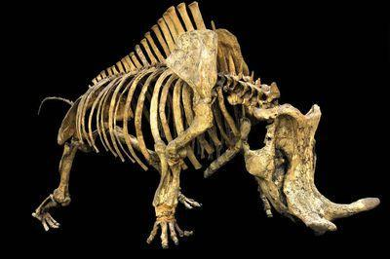

*Brontotheres*, pictured below, are relatives of horses and rhinoceroses that went extinct about 35 million years ago. The fossil record reveals that *Brontotheres* primarily lived in North America and Asia, which were connected by land bridges exposed by lower sea levels.

The phylogeny below, created from fossil data, shows the relationships among different brontothere taxa. Colors of branches and tips indicate whether the species lived in North America or Asia (based on where the fossil was recovered).

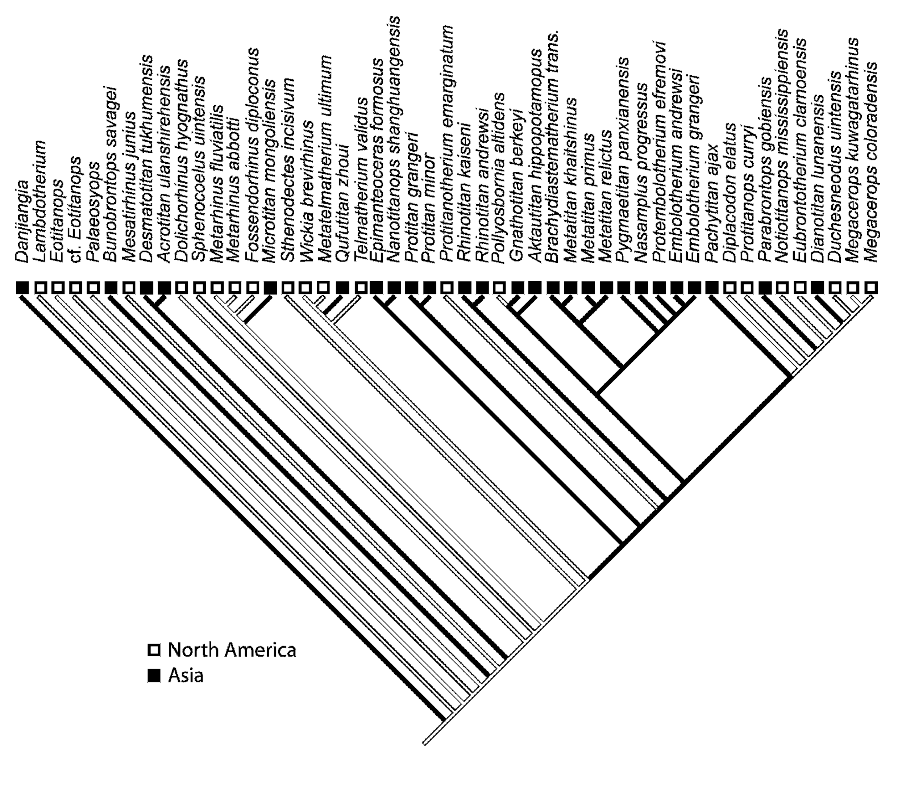

**Assuming the most parsimonious answers…**

How many times did brontotheres move from Asia to North America?

How many times did brontotheres move from North America to Asia?

In total, how many times did brontotheres disperse between the two continents during their evolution?

Many different species of shrimp of the genus *Altheus* are found on either side (Pacific Ocean to the southwest and Caribbean Sea to the northeast) of the Isthmus of Panama. This narrow landmass is relatively new geologically and only formed about 3 million years ago. Before 3 million years ago, the Pacific and Caribbean were directly connected at this location. 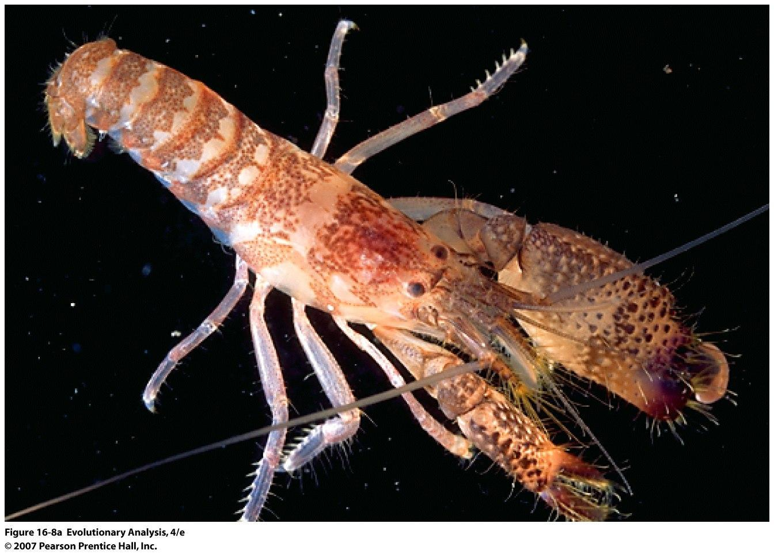

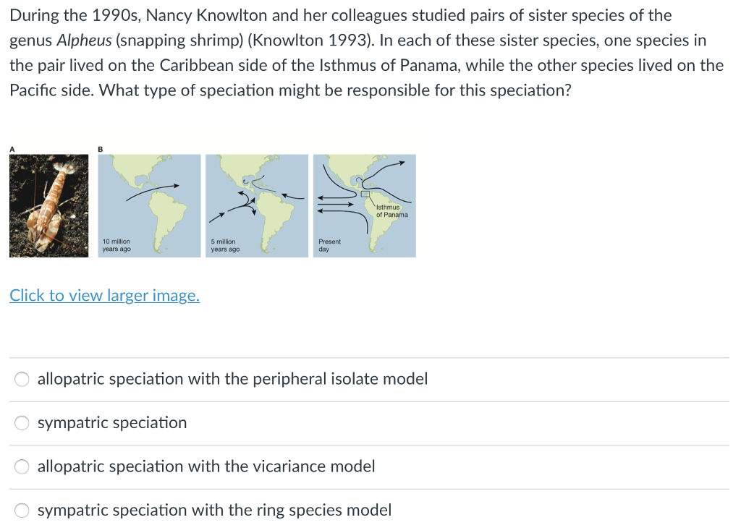

Assume there are now five species of shrimp that live on either side of the isthmus (10 species total). Below are two scenarios that describe how these species could have originated. Draw a phylogeny that depicts each scenario. Also, within each scenario, identify circumstances of sympatric and allopatric speciation.

1. Assume before the isthmus formed there were FIVE distinct species of shrimp. After the formation, some of each species were left on either side of the isthmus. Over the next 3 million years, shrimp left on each side continued diverging.
2. Assume before the isthmus formed there was a SINGLE species of shrimp. After the formation, shrimp on either side of the isthmus speciated into five new species each.